Medical history & cause of admission
Subjective
Name: Ramadan Abd El hares Dewedar
Age: 57 years old a
Medical history: Diabetes mellitus on Amaryl (glimepiride)
Date of admission: 21/6
R.M admitted with post operation elevation of compound depressed left frontoparietal fracture
Condition started by falling hard object on head >>> come to ER F.C
Under general anesthesia >>>> elevation depressed bone
Dural repair by primary suture
Received 4L crystalloid, 1PRBCS >>>1L blood loss
Refer to ICU >>> ETT
Objective
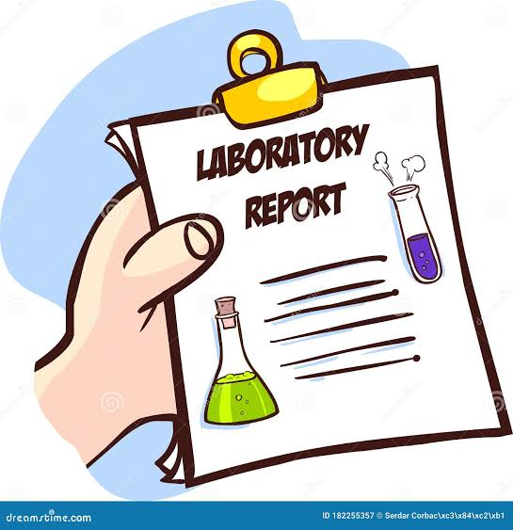
Vital signs

Data | 21/6 | 22/6 | 23/6
Temp | 37 | - | 37.5
BP | 210/100 | - | -
BGL | 227 | 171 | 159
Lab
parameter | 21/6 | 22/6 | 23/6
Scr | 0.8 | 0.86 | -
Na | 139 | 146 | 143
K | 4.29 | 3.97 | 4.74
Ca | 8.7 | 9.19 | -
Mg | 2.45 | 1.97 | -
Alt / Ast | 33/33 | 22/24 | -
D.Bil | - | 0.216 | -
PT | 13.6 | 13.27 | -
INR | 1.02 | 1.12 | -
Aptt | 80 | 87 | -
WBCS | 10.6 | 9.8 | 12.3
Hgb | 14 | 11.9 | 11.8
Platelets | 173 | 128 | 83
CRP | 10.8 | 128 | 208

Fluid chart
Date | 21/6 | 22/6 | 23/6
Intake | 4020 | 2935 | 3400
Output | 5700 | 2756 | 3000
Net | -1680 | +179 | +400

Arterial blood gas

Date | 21/6 | 22/6 | 23/6
PH | 7.42 | 7.31 | 7.47
CO2 | 44 | 45 | 36
HCO3 | 25.4 | 26.6 | 26.9
Lactate | 1.3 | 1.2 | 1

Radiology
CT brain: compound left frontoparietal depressed
CT cervical: UR
CT chest: bilateral basal infiltration aspiration >> community acquired pneumonia (CAP)
ECG: NSR
Case problems
- Traumatic brain injury (TPI)
- Community acquired pneumonia (CAP)
Traumatic brain injury (TPI)

Traumatic brain injury (TBI) is defined as an alteration in brain function or other evidence of brain pathology, caused by an external force
ETIOLOGY
  - Unintentional falls
  - Motor vehicle crashes
  - Unintentionally being struck by or against an object
  - Intentional self-harm
  - Assault
  - Contact sports

RISK FACTORS
Alcohol and drug use
prior/recurrent head injury
contact sports, seizure disorder
ADHD (attention deficit hyperactivity disorder)
male sex
Clinical severity classification
TBI is classically categorized using the Glasgow Coma Scale (GCS)
as:
•mild (GCS score 14 through 15)
•moderate (GCS score 9 through 13)
• severe (GCS score 3 through 8)

Management:

First-Line
- Pain control is important in patients with a TBI. In individuals with severe brain injuries who can’t communicate, there are scales such as the Nociception Coma Scale (NCS) that can be used
- Increased ICP
- Hypertonic saline: 2 mL/kg IV decreases ICP without adverse hemodynamic status; preferred agent
- Mannitol: 0.25 to 2.00 g/kg (0.25 to 1.00 g/kg in children) given over 30 to 60 minutes in patients with adequate renal function. Prophylactic use is associated with worse outcomes
- Sedation
  - Propofol: preferred due to short duration of action. Avoid high doses to prevent propofol infusion syndrome. When combined with morphine, it can also effectively decrease ICP and decrease use of other meds
  - Midazolam: similar sedating effect to propofol but may cause hypotension
  - A systematic review that no one sedative agent is more efficacious than the other for improvement of patient-centered outcomes, ICP, or CPP in critically ill adults with severe TBI

Seizure Prophylaxis:
- Recommended as an option for prevention of early
posttraumatic seizures (first 7 days after event)

- Phenytoin most commonly recommended agent (because
of support for use from prospective clinical trials)
15 mg/kg IV (1 mg/kg/min IV, not to exceed 50 mg/min)
- Levetiracetam also commonly used.
Initial: IV: 500 mg to 1 g intraoperatively prior to incision
Maintenance: IV, Oral: 1 g/day in 2 divided doses; usual dosage range: 500 mg to 3 g/day
adjust dose based on response and tolerability

- Valproic acid is as effective as phenytoin, but a trend toward
increased mortality was observed in a prospective clinical
trial, so it is not a first-line agent.

ALERT
Avoid corticosteroid use because it increases mortality rates and risk of developing late seizures

Community acquired pneumonia (CAP)

It is a lung infection that can cause coughing, fever, and trouble breathing . The lung infection is often caused by bacteria, but it can also be caused by viruses or other germs
Likely Pathogens
Chlamydia pneumoniae
Haemophilus influenzae
Legionella pneumophila
Moraxella catarrhalis
Mycoplasma pneumoniae
Respiratory viruses (eg, influenza, parainfluenza, respiratory syncytial virus)
Staphylococcus aureus, methicillin-susceptible and methicillin-resistant
Streptococcus pneumoniae (most common bacterial pathogen)

Common symptoms include:
● Cough – People sometimes cough up mucus (sputum).
● Fever
● Chest pain, especially when taking a deep breath
● Fast heartbeat
● Shaking chills
Management of CAP in ICU:
No risk factors for Pseudomonas:
One of the following:
Ampicillin and Sulbactam
Cefotaxime
Ceftaroline
Ceftriaxone
Ertapenem
Plus one of the following:
Macrolide (azithromycin, clarithromycin)
Respiratory fluoroquinolone (gemifloxacin, levofloxacin, moxifloxacin)
Plus, if risk factors for MRSA, one of the following:
Linezolid
Vancomycin
Risk factors for Pseudomonas:
One of the following:
Cefepime
Ceftazidime
Imipenem and Cilastatin
Meropenem
Piperacillin and Tazobactam Sodium
Plus one of the following:
Ciprofloxacin
Levofloxacin
Plus, if risk factors for MRSA, one of the following:
Linezolid
Vancomycin

Medication tables

Drug | Dose | Starting date | End date | Note
ceftriaxone | 2gm*100ml NS/8hr | 21/6 | 22/6 | Not indicated
Ampicillin &sulbactam | 1.5gm*100ml NS/8hr | 21/6 | 22/6 | Indicated for CAP
meropenem | 1gm*100ml NS/8hr | 22/6 | ------ | Not indicated
metronidazole | 500mg/8hr | 21/6 | 22/6 | Not indicated

Drug | Route of  administration | Dose/Frequency | Indicated or not | 21/6 | 22/6 | 23/6 | 24/6
NS | IV | 500ml/12hr | Indicated for fluid resuscitation
Ringer | IV | 500ml/12hr | Indicated for fluid resuscitation |  |  |  | D.C
Omeprazole | IV | 40mg*100ml NS/24hr | Indicated for ulcer stress prophylaxis
B.com | IV | Amp*100ml NS/24hr | Supplement
Levetiracetam | IV | 1gm*100ml NS/12hr | Indicated for seizure prophylaxis
Tranexamic acid | IV | Amp*100ml NS/8hr | Not indicated |  | D.C | D.C
Fentanyl | IV infusion | 5amp*50ml NS by 5ml/hr | Indicated for analgesia |  | 10ml/hr
Midazolam | IV infusion | 5amp*50ml NS BY 10ml/hr | Indicated for sedation |  |  | 5ml/hr
Dexamethasone | IV | Amp/12hr | Not indicated
Paracetamol | IV | 1000mg/8hr | Indicated for analgesia
Ipratropium | Inhalation | 500mcg/6hr | Indicated for bronchodilatation
Budesonide | Inhalation | 0.5mg/8hr | Indicated for asthma prophylaxis
Hexitol | Mouth wash | Every 6hr | Indicated for oral care
Tears guard | Eye drop | Every 6hr | Indicated for eye care
Adrenalin | Inhalation | Every 6hr | Indicated in laryngeal edema
Alphintern | Oral tablet | 2tab/8hr | Indicated in laryngeal edema
acetylcysteine | IV | 300mg/8hr | Indicated as mucolytic

Plan of treatment
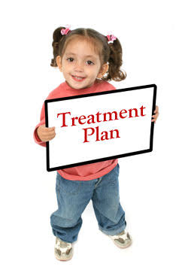

FAST HUGS BID
Feeding: enteral
Analgesia: paracetamol 1gm/8hr
Fentanyl 5amp*50ml by 5ml/hr
Sedation: midazolam 5amp*50ml by 10ml/hr
Thromboprophylaxis: not managed
Head of bed elevation: elevate the head of the bed by 45 degrees
Ulcer (stress) prophylaxis: omeprazole 40mg IV/24hr
Glucose control: the patient within the target
(140-180 mg/dl)
Spontaneous breathing trial: the patient is not mechanically ventilated
Bowel regimen: pass stool
Indwelling catheter line: pl
De-escalation of antibiotics: the patient was on empirical antibiotics therapy, then some of unneeded antibiotics were stopped (ceftriaxone) but still meropenem used and should be stopped

Drug interaction
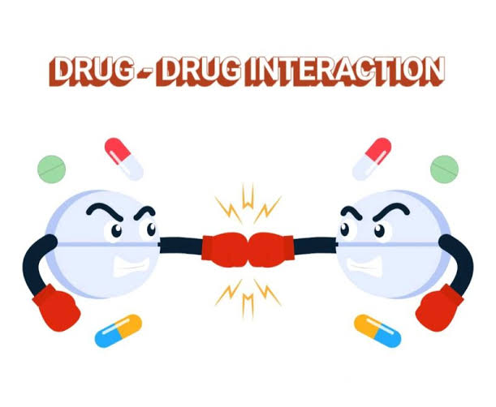
Fentanyl + midazolam
Category: D (modify)
Severity: major
CNS Depressants may enhance the CNS depressant effect of Opioid antagonist
Management: avoid concomitant use of opioid antagonists and benzodiazepines or other CNS depressants when possible. these agents should only be combined if alternative treatment options are inadequate.
If combined limit the dosages and duration of each drug to the minimum possible while achieving the desired clinical effect and consider dose reduction of opioid or CNS depressant upon initiation

Drugs modification
Drug | Problem | Action
acetylcysteine | Wrong dose  (300mg/8hr) | Correct dose  (300mg/12hr)
paracetamol | Fentanyl use in infusion rate to control pain  No fever  So no need for 1000mg paracetamol /8hr | Preferred to be 1000mg PRN

Drugs to be stopped or substituted
Drug | Problem | Action
Tranexamic acid | Not indicated further  LD: 1gm over 10min started within 3hr of injury, followed by 1gm over the next 8hr as a continuous infusion | Should be stopped
dexamethasone | Avoid corticosteroid use because it increases mortality rates and risk of developing late seizures in TPI | Should be stopped
ceftriaxone | Not indicated | Should be stopped
Metronidazole | Not indicated | Should be stopped
Meropenem | Not indicated in CAP in case of no risk factor for Pseudomonas | Should be stopped and substituted by  Ampicillin & sulbactam (1.5gm/8hr)  +  azithromycin 500mg /24hr

Drug to be added
DVT prophylaxis agent should be added

Venous thromboembolism (VTE) prophylaxis
Patients with TBI have an increased risk of VTE because of:
I. Delay in initiation of pharmacologic VTE prophylaxis
II. Immobility
III. Concomitant injuries (in the case of polytrauma)
Mechanical prophylaxis should be initiated as soon as possible.
Pharmacologic prophylaxis should be initiated after intracranial
bleeding is stabilized.
i.Typically, 24–48 hours after event
ii. May depend on coagulopathy on admission, extension of
bleeding on CT scan, and other factors
iii. Unfractionated heparin or low-molecular-weight heparin
(LMWH) may be used for pharmacologic prophylaxis.
References
Lexicomp
UpToDate
Genebrandex

